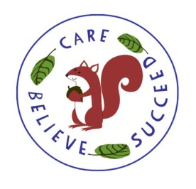

**Homework**

Our expectations this week for homework are as follows:

* Reading: Daily (recording in their Reading Records at least 3x weekly, diaries are collected in on a Monday)
* PSP (Personalised Spelling Programme) Spellings.
* Maths: Times table sheet and Seesaw SATs Practice Questions
* English Grammar: Seesaw SATs Practice Questions
* Europe including France Self Directed Study – PowerPoint on Office 365

**Contact Info**

[r.reed@montnicolle.sch.je](mailto:r.reed@montnicolle.sch.je)

[j.campbell@montnicolle.sch.je](mailto:j.campbell@montnicolle.sch.je)

[m.michel@montnicolles.ch.je](mailto:m.michel@montnicolles.ch.je)

**Self-Directed Study**

This term’s topic is Europe including France. The children are being asked to complete a PowerPoint around this title.

**English**

We have a wonderful selection of texts for this term.

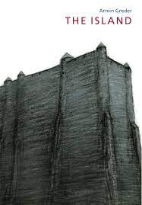 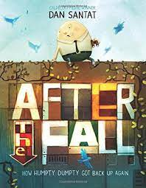 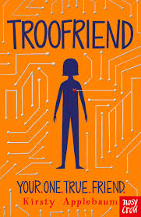

We will start the term with the text ‘The Island’. This text also forms the basis for our ‘No Outsiders’ work. We will be writing letters as the outcome to this text.

Our Guided Reading text for this term is ‘Troofriend’. It is a story about an android who begins to develop human feelings. It explores the ups and downs of friendships and feelings which makes it a great text to support transition to secondary school.

We will be revisiting our grammar learning from the year and ensuring that we really understand it and can use it in our writing.

**P.E.**

Year 6A – Tuesday and Friday

Year 6B – Wednesday and Friday

The first half term will be cricket and volleyball and the second half term will be team games and athletics.

**Computing**

This term we will be learning about online safety and developing our word processing skills.

**Science**

This term we will be learning about the circulatory system. We will be learning about the organs in this system and their roles. We will look at how nutrients are transported around the body and we will look at the effects of food, exercise, drugs and alcohol on our bodies.

**Geography**

We will be learning about Europe with a particular focus on France. We will be exploring the mountains in France as well as looking at trade links across the UK and Europe.

**Transition**

This term we will do lots of work around transition and getting ready for secondary school. We will spend time talking and asking and answering questions.

**P.S.H.E**

During the first half term we will be learning about keeping our bodies fit and healthy and about what effects our mental health positively and negatively.

During the second half term, we will be learning how to manage ourselves and how to manage risk.

**Maths**

The topics we will be covering this term are:

Chapter 10 – Area and Perimeter

Chapter 11 – Volume

Chapter 12 – Geometry

Chapter 13 – Position and Movement

Chapter 14 – Graphs and Averages

Chapter 15 – Negative Numbers

**Year 6 Summer Term Overview 2022**