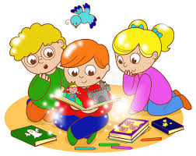
Personal, Social & Emotional Development
For this term we will be supporting the children with further independence and ensuring that they can select resources needed for a specific activity and supporting their organisation.
Communication and Language
We will be continuing our focus on answering ‘how’ and ‘why’ questions and encouraging the children to extend their language with connectives such as ‘because’ or ‘and’ to add additional detail to what the children are saying.

Key information
In our final term, the children will be working towards their Early Learning Goals across the Curriculum in preparation for Year 1.
Monday – PE (Dragos Dance)
Tuesday- Forest School
Forever Friends Ceremony - TBC
Key adults
Mrs Couley – Teaching assistant
Mrs Godfray - RWI tutor
Mrs Deacon – Lunchtime supervisor

Physical Development
For the whole term we are lucky to have Dragos come into school for dance sessions. These sessions will begin after the bank holidays every Monday afternoon for an hour.
Understanding the World
In this final term, we will be observing the seasonal changes from Spring to Summer and our raspberry and strawberry plants in our garden. In RE we will be looking at weddings and towards the end of half term, we will be holding our ‘Forever Friends Ceremony’ where the children will conduct a wedding based on friendship.
We will also be looking to go into the ICT Suite and begin to practise logging on to the computers.

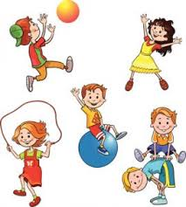

Literacy
Our text drivers for the term are as follows:
Blue Chameleon
If the Dinosaurs came back
The Night Pirates
Super Stan
As usual, we have left space to follow the children’s interest and select books around themes that they show a current interest in.
Read Write Inc will be continuing as per normal.


Expressive Arts & Design
This term we are going to continue exploring a wide range of different materials when at the art table. The children will be encouraged to think about changing certain elements of their models and pictures to enhance and improve them.

Mathematics
This half term we will be covering one area of Mathematics learning a week and assigning a weekly mini maths challenge on Seesaw.
These areas are;

- Halving
- Doubling
- Sharing
- Comparing weight
- Recognising and ordering numbers to 20

It is important for the children to have a good understanding of numbers to 20 by the end of this term and know some number bonds to 10.

