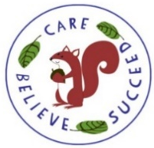
English
This term, we will be covering a variety of exciting texts in English which will change every 2-3 weeks. Each Learning Journey will involve a mixture of reading, role-play and writing tasks related to the text driver, all geared towards producing a writing outcome at the end of each unit. When we start a new text, I will let you know in my weekly email which text it is, and what we are learning through it. I will be aiming to link my text choices to our Science, Geography and History topics.

Guided Reading sessions will also take place once a week. The children will read with either myself or Mrs Deacon. They will bring home the book they have read in class to read again at home. Please can I ask that the book is returned to school in time for the following Guided Reading session. Session days may vary, so it would be a good idea to keep Reading Journals and books in their book bag at all times so that they are always accessible in school.

We will also have weekly handwriting lessons in class.
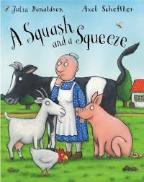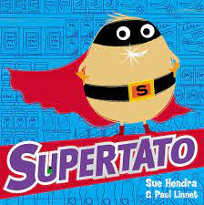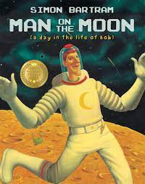

Year 1 Summer Term Overview 2022

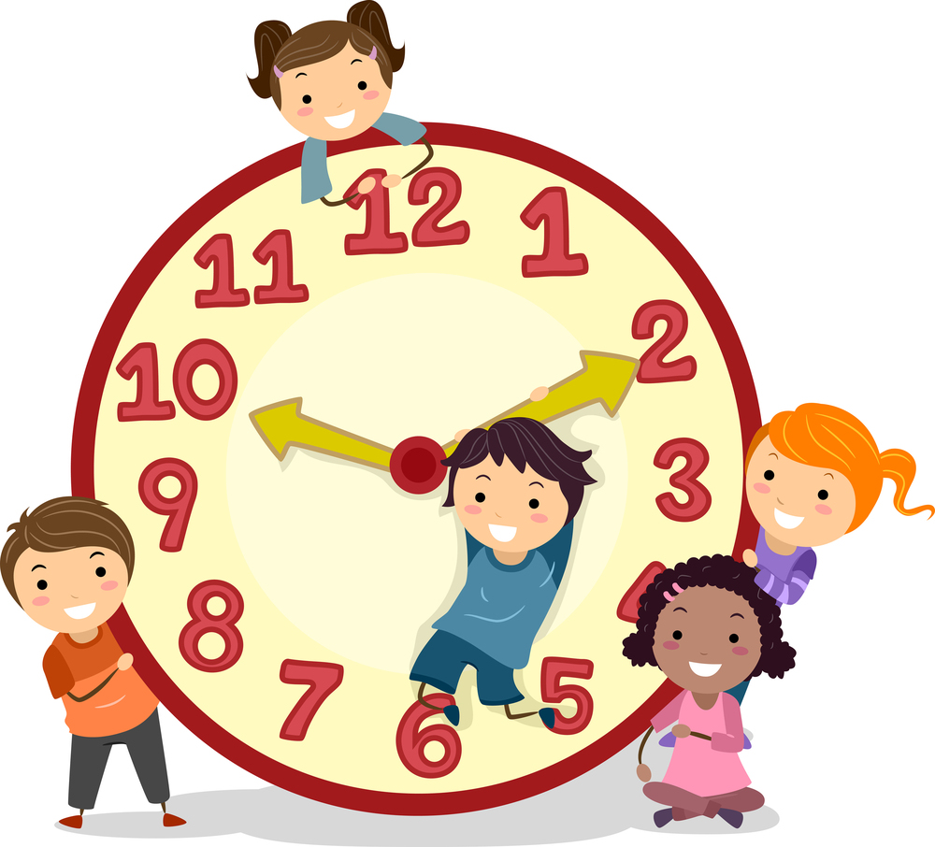
Maths
This term, we will cover the following units:
Chapter 12- Multiplication
Chapter 13 – Division
Chapter 14 – Fractions
Chapter 15 – Numbers to 100
Chapter 16 – Time
Chapter 17 – Money
Chapter 18 – Volume & Capacity
Chapter 19 – Mass
Chapter 20 – Space
Maths homework will continue to be set on Seesaw every other week. I will inform you of this in my weekly emails. Homework activities will be linked to what we have been learning about in class and an opportunity for your child to consolidate this further.

PE
Our main focuses for this term will be Dance, Athletics, Net and Wall games, Teambuilding and Striking/Fielding games.

Geography
This half term, we will be learning about ‘Hot and Cold Countries’. This will involve learning about weather and seasonal changes as well as identifying the equator on a globe and learning which countries are hot and which are cold.

Key information
Monday
Indoor P.E.
Tuesday
Library
Forest School
Thursday
Outdoor P.E

History
After May half term, we will be learning about Famous Explorers!
The children will be learning about the lives and adventures of Neil Armstrong and Christopher Columbus.

Art
In the first half term, we will be learning about making Primary and Secondary colours with paint. 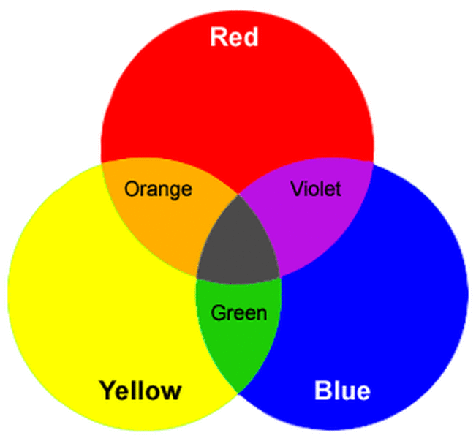
In the second half term, we will be learning to weave different materials such as paper and wool.

Science
Our focus for this term will be on ‘Plants’. We will be learning about what a plant or tree needs to survive and to describe the basic structure of a variety of common flowering plants, including trees.
We will be carrying out two exciting growing experiments with cress and then broad beans!

ICT
Our focus this term will be learning about online safety. The children will learn about keeping their personal information safe and what to do if they are worried about something they have seen or experienced online.

