Geography
This half term, we will be learning about ‘Jersey and Africa’.
We will locate both places on a world map and describe their location in relation to the equator, continents and oceans. We will explore and look at geographical similarities and differences between Jersey and Kenya, including rural and urban settings.

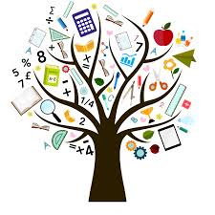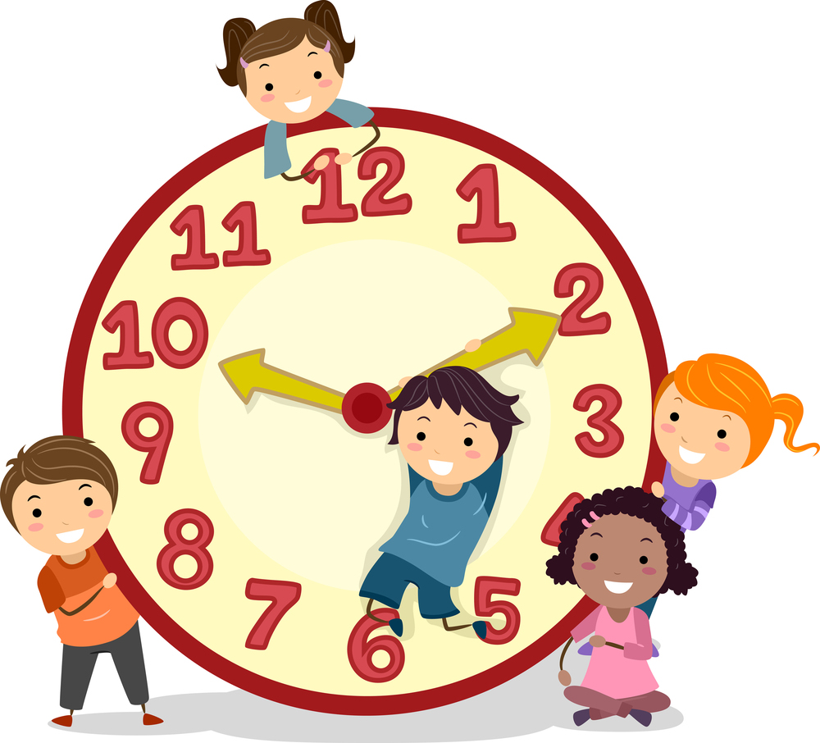
Maths
This term, we will cover the following units:
Chapter 10 – Money
Chapter 11 – 2D Shapes
Chapter 12 – 3D Shapes
Chapter 13 – Fractions
Chapter 14 – Time
Chapter 15 - Volume
Maths homework will continue to be set on Seesaw every other week. I will inform you of this in my weekly emails. Homework activities will be linked to what we have been learning about in class and an opportunity for your child to consolidate this further.

Key information
Tuesday
Indoor P.E
Library
Thursday
Forest School (every other week)
Friday:
Outdoor P.E

Year 2 Summer Term Overview
2022

English
This term, we will be covering a variety of exciting texts in English which will change every 2-3 weeks. Each Learning Journey will involve a mixture of reading, role-play and writing tasks related to the text driver, all geared towards producing a writing outcome at the end of each unit. When we start a new text, I will let you know in my weekly email which text it is, and what we are learning through it. I will be aiming to link my text choices to our Science, Geography and History topics.

Guided Reading sessions will also take place twice a week. The children will read with either myself or Miss Le Gresley. They will bring home the book they have read in class to read again at home. Please can I ask that the book is returned to school in time for the following Guided Reading session. Session days may vary, so it would be a good idea to keep Reading Journals and books in their book bag at all times so that they are always accessible in school.
We will also have weekly handwriting lessons in class.

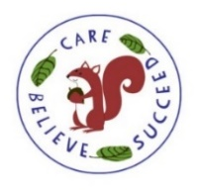

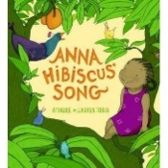
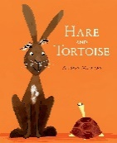
Science
In the first half term we will be learning about Animals including Humans. We will learn about the offspring of a variety of animals and the different ways that animals reproduce. We will also learn about basic needs for survival and how humans grow as they get older. In our classroom, we will be observing the process of how live caterpillars grow into butterflies.

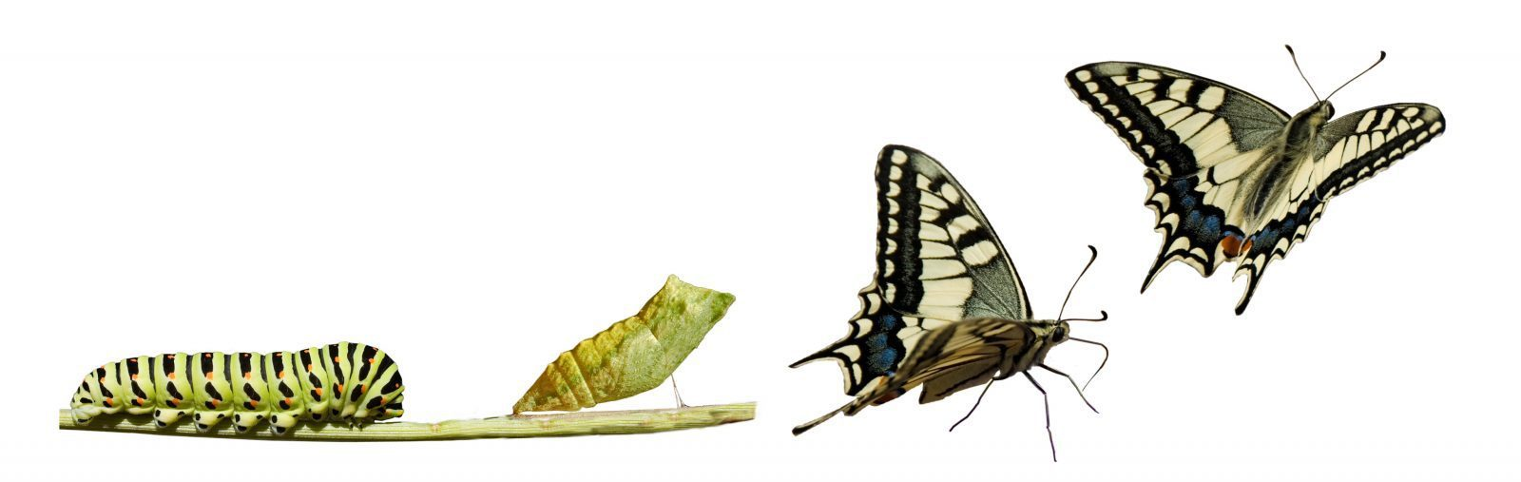

After May half term, our focus will be on ‘Plants’. We will be planting our own seeds and bulbs to observe and describe how they grow into mature plants. We will also be learning about what plants need to stay alive.

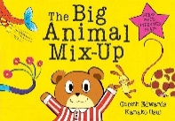
Art
In the first half term, we will be learning about the African artist Esther Mahlangu. We will be using shape, patterns and vibrant colours to create some of our own artwork inspired by her.

After May half term, we will be making 3D fairy sculptures as part of the Jersey ‘Map of Wonders’ project.

RE
This term, we will be learning about Sikhism. We will learn about the different Gurus and some stories associated to Guru Nanak. We will also learn about the ‘Gurdwara’ and some of the special parts in the Gurdwara.

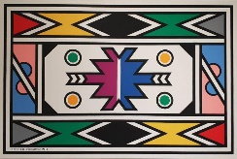

ICT
Our focus this term will be learning about online safety. The children will learn about keeping their personal information safe and what to do if they are worried about something they have seen or experienced online.
PE
Our main focuses for this term will be Dance, Net and Wall games, Teambuilding and Striking/Fielding games.

History

After May half term, we will be learning about Elizabeth Castle and The Battle of Jersey.

