Characteristics of Effective Learning
In the Foundation Stage we primarily focus on developing key learning skills and dispositions that will be fundamental to every child’s success in their lifelong learning journey.
Playing and exploring
Finding out and exploring
Active Learning
Being involved and concentrating
Creating and thinking critically
Having their own ideas
Personal, social & Emotional Development
This term our main focus will be to continue to support children to make a range of friendships within Nursery.
We will be looking at children initiating and holding conversations with both their peers and adults.
We will continue to work on building resilience in Nursery and children being able to adapt to changes in routine. This will especially help as we begin to think about moving into Reception!

Days to note
Sun cream to be applied daily before coming into Nursery. Sun hats to stay in Nursery.
Tuesday: P.E
Thursday: Forest School. Children must have their legs and arms covered

Physical Development
PE days have moved back to Tuesdays and will now be in the afternoon. For the first half term, we will be taking part in Dance lessons led by a dance teacher called Dragos.
We will also be taking part in the school’s Festival of Sport week, where we will be walking/running a mile and taking part in a PE activity every day.

Communication and Language
We will continue with weekly ‘group time’ sessions where children are encouraged to talk about their weekend and share their thoughts and opinions with their peers. We encourage conversational skills in Nursery, whether that be during snack time or problem solving and negotiating with others.
We will be having lots of discussions on how to be safe in and out of Nursery and will place lots of emphasis on using words such as he, she, her and him correctly in conversations.

Daily routines:

The children’s independence is flourishing in Nursery. They are gaining so much self-confidence from doing their own daily jobs. We are continuing to support children in putting on socks and shoes independently along with attempting buttons and zips. Thank you for your continued support in this area.

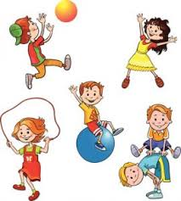
Understanding the World
To celebrate both Liberation Day and the Queen’s Jubilee we will be learning about Jersey and its surroundings as well as new and old toys/objects etc. We will also look at how we can keep ourselves safe both on the road and in the sunshine.
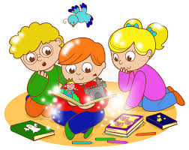

Mathematics
We will be using mathematical language such as long/longer/longest to describe objects.
We will also look at using language such as full and empty to describe capacity.
Literacy
This term we will be focusing on writing our names using the correct letter formation.
We will continue to learn letters and the sounds that they make. I will inform you in the weekly newsletter what sounds we have learnt each week.
We will be working on giving meaning to marks we make and will start to attempt to form letters using the correct formation.

REAL
Raising Early Awareness in Literacy.
This term we will be focussing on engaging children in a number of literacy-based activities. We will be visiting our school library weekly to look at and share books. We will be setting up a lending library where your child can choose a book to take home and read with you. We also hope you visit the local library and have the opportunity to sign up for a library card.

Expressive Arts & Design
This term we continue to be focussing on children gathering their own resources to make their creations including pouring and using paint independently.

